

School of Electronics Engineering
Winter Semester 2023-24
Programme : B.Tech (ECE) CAT-II
Course Code : BECE401L Course Name : Computer Communications and Networks Slot : D2+TD2 Class ID : VL202324
Date of Exam :04-04-24 Session : FN : Max 50 Marks
Q.No | Question | Max Marks | CO | BL
1 | - Suppose that aaa@xxx.com wants to send an email to bbb@yyy.com that is far away from the sender computer. Draw and explain the typical email operation.  - Find the given domain is either generic or country specific or inverse domain.  - xxx.gov.cn Country  - yyy.gov Generic  - 132.128.10.11 Inverse  - zzz.int Generic  - 192.145.129.255 Inverse  - yyy.edu.in Country | 4 + 6 | CO - VI | BL2
2 | The following corresponds to an HDLC ABM frame exchange. Consider 3 bits to represent the sequence number. Complete the diagram by completing the labeling of the frame exchanges.  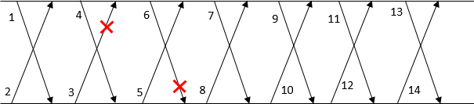  1) BI00 2) AI00 3) AI11 4) BI11 5) AI22 6) BI21 7) AREJ1  8) BREJ2 9) BI21 10) AI12 11) BI32 12) AI23 13) BI43 14) AI34 | 10 | CO - III | BL3
3 | I). In the data link layer of a computer network, bit-oriented framing and bit stuffing method is applied. Assuming that 01110 bit string is used as the starting and ending delimiter.  a). At the sender, if the bit string delivered by the network layer to the data link layer is given as follows, obtain the bit string at the data field of the sender’s data link layer.  1 0 1 1 1 1 1 1 0 0 1 1 1 0 0 0 1 1 1 1  01110 10110110110001101000110110 01110  b). At the receiver, if the bit string delivered by layer 1 to layer 2 is as follows, obtain the bit string before bit stuffing.  0 1 1 1 0 0 0 1 0 1 0 0 1 1 0 0 1 1 0 1 1 0 0 0 1 1 0 0 1 1 0 1 0 0 0 1 1 1 0  0 0 1 0 1 0 0 1 1 0 1 1 1 1 0 0 1 1 0 1 1 1 0 0  II) Selective Repeat Sliding window protocol is used between the data link layers of machines A and B with a 3 bits to represent the sequence number at both sides. The figure below shows the a0 and b0 states of the sliding windows of machines A and B, respectively. Indicate the frame numbers that should be contained in the sliding windows and buffer memories at the sender and receiver for the states a1, b1, a2, b2, a3, b3, a4, and b4.  (6Marks)  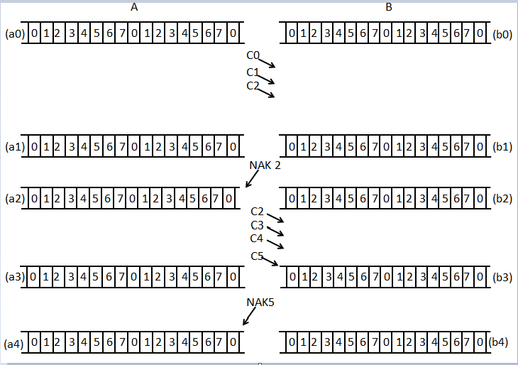 | 4 +6 | CO - III | BL3
  State | Frame sequence in Send Window | State | Frame sequence in Receive Window
  a0 | 0,1,2,3 | b0 | 0,1,2,3
  a1 | 3 | b1 | 3
  a2 | 2,3,4,5 | b2 | 2,3,4,5
  a3 | { } | b3 | {}
  a4 | 5,6,7,0 | b4 | 5,6,7,0
4 | The below figure shows a site with a given network address and mask. The administration has proposed to make five subnetworks as shown in the figure. The ISP has allocated the IP ADDRESS: 195.223.50.0 for this site. Using this IP address, to start the subnet from 2nd subnet:  - Find the range of Host IDs assigned to each subnet.  - Assign 1st host ID of each subnet as the gateway address.  - Node1 assigned the 2nd host id and node number n assign the last host id.  - Router1 and Router 2 serial port to assign first and last usable address in the 6th subnet.  - Find the broadcast ID of each subnet.  - Redraw the network diagram by representing the Host ID, subnetwork ID, gateway address.  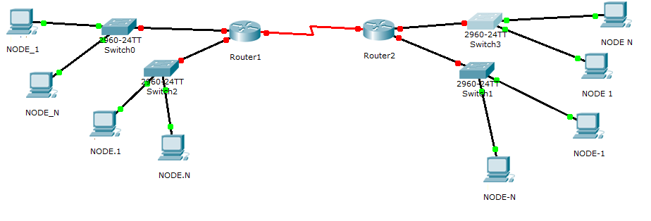 | 10 | CO - V | BL3
  SNID | HID | BID
  195.223.50.32 | 195.223.50.33 - 195.223.50.62, | 195.223.50.63
  195.223.50.64 | 195.223.50.65 - 195.223.50.94 | 195.223.50.95
  195.223.50.96 | 195.223.50.97 - 195.223.50.126 | 195.223.50.127
  195.223.50.128 | 195.223.50.129 - 195.223.50.158 | 195.223.50.159
  195.223.50.160 | 195.223.50.161 - 195.223.50.190 | 195.223.50.191
  195.223.50.192  Router 1 to Router 2 | 195.223.50.193 - 195.223.50.222 | 195.223.50.223
5 | Number of needed subnets 1000 and Network Address 165.100.0.0  Find  - Address class B  - Default subnet mask 255.255.0.0  - Custom subnet mask 255.255.255.192  - Total number of subnets 1024  - Total number of host addresses 64  - Number of usable addresses 62  - Number of bits borrowed 10  - What is the 15th subnet range? 165.100.3.192 - 165.100.3.255  - What is the subnet number for the 1000th subnet? 165.100.250.0  - What is the subnet broadcast address for the 901st subnet? 165.100.225.127  - What are the assignable addresses for the 800th subnet? 165.100.200.1 - 165.100.200.62 | 10 | CO - V | BL3

